**Proof of NP-hard and NP-completeness**

A problem is in the class NPC if it is in NP and is as **hard** as any problem in NP. A problem is **NP-hard** if all problems in NP are polynomial time reducible to it, even though it may not be in NP itself.

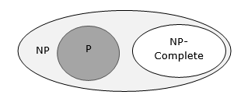

If a polynomial time algorithm exists for any of these problems, all problems in NP would be polynomial time solvable. These problems are called **NP-complete**. The phenomenon of NP-completeness is important for both theoretical and practical reasons.

Definition of NP-Completeness

A language **B** is ***NP-complete*** if it satisfies two conditions

* **B** is in NP
* Every **A** in NP is polynomial time reducible to **B**.

If a language satisfies the second property, but not necessarily the first one, the language **B** is known as **NP-Hard**. Informally, a search problem **B** is **NP-Hard** if there exists some **NP-Complete** problem **A** that Turing reduces to **B**.

The problem in NP-Hard cannot be solved in polynomial time, until **P = NP**. If a problem is proved to be NPC, there is no need to waste time on trying to find an efficient algorithm for it. Instead, we can focus on design approximation algorithm.

**Pictorial representation of all NP classes which includes NP, NP-hard, and NP-complete**

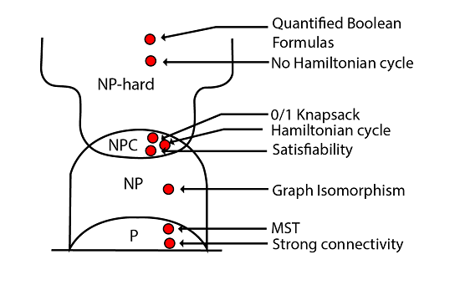

NP-Complete Problems

Following are some NP-Complete problems, for which no polynomial time algorithm is known.

* Determining whether a graph has a Hamiltonian cycle
* Determining whether a Boolean formula is satisfiable, etc.

NP-Hard Problems

The following problems are NP-Hard

* The circuit-satisfiability problem
* Set Cover
* Vertex Cover
* Travelling Salesman Problem

In this context, now we will discuss TSP is NP-Complete

TSP is NP-Complete

The traveling salesman problem consists of a salesman and a set of cities. The salesman has to visit each one of the cities starting from a certain one and returning to the same city. The challenge of the problem is that the traveling salesman wants to minimize the total length of the trip

Proof

To prove ***TSP is NP-Complete***, first we have to prove that ***TSP belongs to NP***. In TSP, we find a tour and check that the tour contains each vertex once. Then the total cost of the edges of the tour is calculated. Finally, we check if the cost is minimum. This can be completed in polynomial time. Thus ***TSP belongs to NP***.

Secondly, we have to prove that ***TSP is NP-hard***. To prove this, one way is to show that ***Hamiltonian cycle ≤p TSP*** (as we know that the Hamiltonian cycle problem is NPcomplete).

Assume ***G = (V, E)*** to be an instance of Hamiltonian cycle.

Hence, an instance of TSP is constructed. We create the complete graph ***G' = (V, E')***, where

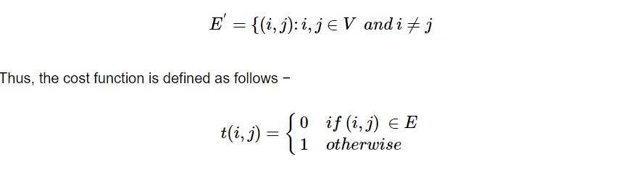

Now, suppose that a Hamiltonian cycle ***h*** exists in ***G***. It is clear that the cost of each edge in ***h*** is **0** in ***G'*** as each edge belongs to ***E***. Therefore, ***h*** has a cost of **0** in ***G'***. Thus, if graph ***G*** has a Hamiltonian cycle, then graph ***G'*** has a tour of **0** cost.

Conversely, we assume that ***G'*** has a tour ***h'*** of cost at most **0**. The cost of edges in ***E'*** are **0** and **1** by definition. Hence, each edge must have a cost of **0** as the cost of ***h'*** is **0**. We therefore conclude that ***h'*** contains only edges in ***E***.

We have thus proven that ***G*** has a Hamiltonian cycle, if and only if ***G'*** has a tour of cost at most **0**. TSP is NP-complete.

**RELEVANT READING MATERIAL AND REFERENCES:**

**Source Notes:**

1. <https://www.tutorialspoint.com/design_and_analysis_of_algorithms/design_and_analysis_of_algorithms_np_hard_complete_classes.htm>
2. <https://www.javatpoint.com/daa-complexity-classes>

**Lecture Video:**

1. https://youtu.be/e2cF8a5aAhE

**Online Notes:**

1. <http://vssut.ac.in/lecture_notes/lecture1428551222.pdf>

**Text Book Reading:**

1. Cormen, Leiserson, Rivest, Stein, “*Introduction to Algorithms*”, Prentice Hall of India, 3rd edition 2012. problem, Graph coloring.

**In addition: PPT can be also be given.**